As the Decade Co-ordinator for the “half-century” alumni/ae of Malvern, I am delighted to announce we are holding a 110th Malvern CI anniversary celebration Saturday May 11, and Sunday May 12, 2013, at the school. All decades are invited and the formal announcement can be found in this month’s (Sept.) Musings.

As many of you will recall, we of the 1950s decade have held three reunions over the past six years. Our first reunion, held at the Balmy Beach Club (BBC) in 2006, drew a crowd of 200 1950s alumni/ae. In 2008. we teamed up with the 1960s alumni/ae and held our Rock & Roll Meets Peace & Love reunion, also at the BBC, attended by over 250 people! The M.C.I. band and vocalists, led by Bill Mighton (Music Director at MCI) were fabulous!
A selection of photos from the 2006 and 2008 reunions can be found in the Photo Albums which I have included at the end.
ROCK & ROLL MEETS PEACE & LOVE REUNION
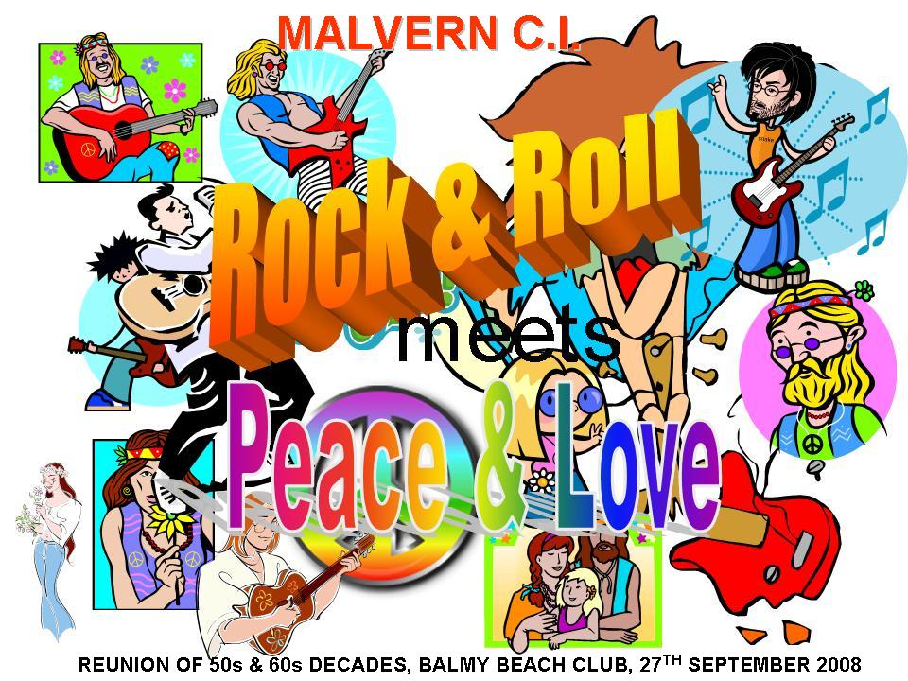

In 2011, our third reunion focused on the theme Musically Malvern, featuring the M.C.I. senior dance band, led by Mike Falla (the new Music Director at Malvern). and as a special treat, an alumni/ae band organized by Gord Moore, also a member of this band,. The band was under the direction of George McRae, and that renowned jazz musician and Malvern graduate, Russ Little participated as well. A special commemorative issue of the Musings, compiled by our MRBS Editor Adele Ashby, featuring stories and photos related to the music programme at Malvern, was given to all registered attendees. Over 300 alumni/ae attended this event. The reader may like to see a selection of photos from this reunion that is shown in the Photo Album section.

Our next reunion will be an all-decades gathering at Malvern on May 11 and 12th, 2013--our first two-day reunion. The Registration desk will open at 9:00 a.m. on Saturday May 11th for alumni to pick up their name tags, a book on “Malvern at 110” (included in the registration fee), a souvenir issue of the Musings and an Event Program. It will commence at 10:00 a.m. in the Auditorium with an Opening Ceremony featuring the Alumni Band. Decade rooms will be available all day for alumni to visit and meet old friends and colleagues, and relive memories of their days at Malvern. A gymnasium will feature historical artifacts associated with our various sporting teams and victories, and a room will be set aside to highlight Malvern’s musical history. To liven up the atmosphere, we will be featuring music in the larger gymnasium by the Malvern Senior Dance Band and the Malvern Senior Choir (directed by Mike Falla) who will be entertaining us with music highlights from the past, and encouraging the alumni to take to the dance floor. A refreshment tent will be set up in the front garden area to provide preordered box lunches (see the pre-registration form in the September issue of the Musings; also on this web site) and non-alcoholic beverages. Picnic tables will be there to allow alumni to meet and greet their friends. After a fun day at the school, some alumni may wish to attend their decade pub night (see the pre-registration form), or go for a Boardwalk Stroll, hosted by a local historian, Gene Domagala (see his web site to get an idea of the treat you will enjoy!) If interested, complete the pre-registration form and mark this event early!

http://www.travelandtransitions.com/interviews/gene_domagala.htm#.UFdQ8kOh4Ns.email

Sunday’s activities commence with a Ceremonial Gathering at the War Memorial at 10:00 a.m., followed by revisiting the school decade rooms, or participating in a historic walk through times past in the afternoon. A lecture on the Beaches’ history will also be given after the walking tour. If any of these activities interest you, please complete the pre-registration form and let us know you are coming. Early registration is encouraged!

REUNION PHOTO ALBUMS
Selection of photos from the 2011 Reunion “Musically Malvern”
Note: click on a picture to enlarge it

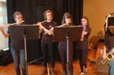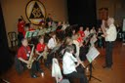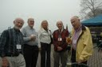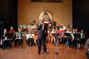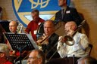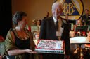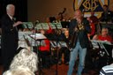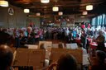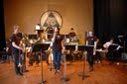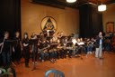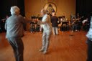

Selection of photos from the 2008 Reunion “Rock & Roll Meets Love & Peace”



